**FEELING ADVENTUROUS?**

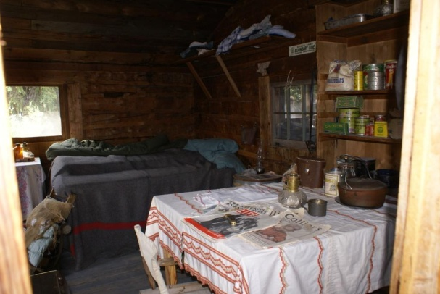

**Spring Break**-*Blast to the Past*. Settlers Resort is like a page right out of a history textbook! Spend five days living in the 1800s.

* One-room cabins with potbelly stoves
* Campfire dining with authentic meals
* Horseback riding and much more

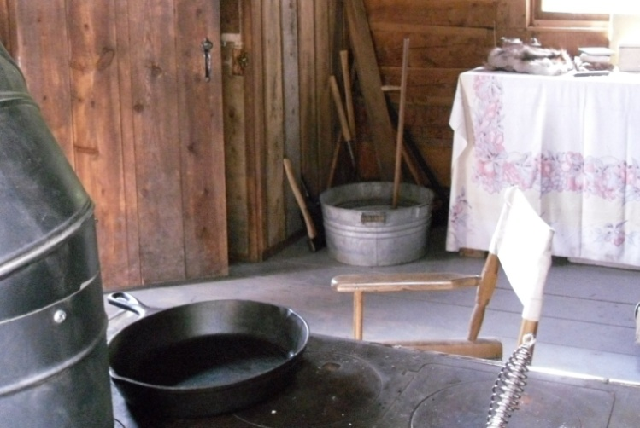

Call Lyn at *555-9901* to sign up!